1.What Is Software?

- Software is a set of instructions, data or programs used to operate computers and execute specific tasks. It is the opposite of hardware, which describes the physical aspects of a computer. Software is a generic term used to refer to applications, scripts and programs that run on a device. It can be thought of as the variable part of a computer, while hardware is the invariable part.

2.What Is Software Engineering?

- Software is a program or set of programs containing instructions that provide the desired functionality. Engineering is the process of designing and building something that serves a particular purpose and finds a cost-effective solution to problems.

3.Explain types of software?

- The two main categories of software are application software and system software. An application is software that fulfills a specific need or performs tasks. System software is designed to run a computer's hardware and provides a platform for applications to run on top of.

4. What is SDLC?

- he software development lifecycle (SDLC) is the cost-effective and time-efficient process that development teams use to design and build high-quality software. The goal of SDLC is to minimize project risks through forward planning so that software meets customer expectations during production and beyond. This methodology outlines a series of steps that divide the software development process into tasks you can assign, complete, and measure.

5. Explain each phase of SDLC?

- A full SDLC has 7 basic stages: Planning, requirements, design and prototype, software development, testing, deployment, and maintenance. In some cases, depending on different variables (project, team, manager, etc.), certain steps can be omitted, split, or combined.

6. What is DFD?

- Data Flow Diagram (DFD) represents the flow of data within information systems. Data Flow Diagrams (DFD) provide a graphical representation of the data flow of a system that can be understood by both technical and non-technical users. The models enable software engineers, customers, and users to work together effectively during the analysis and specification of requirements.

7. Create a DFD diagram on Flipkart?

- 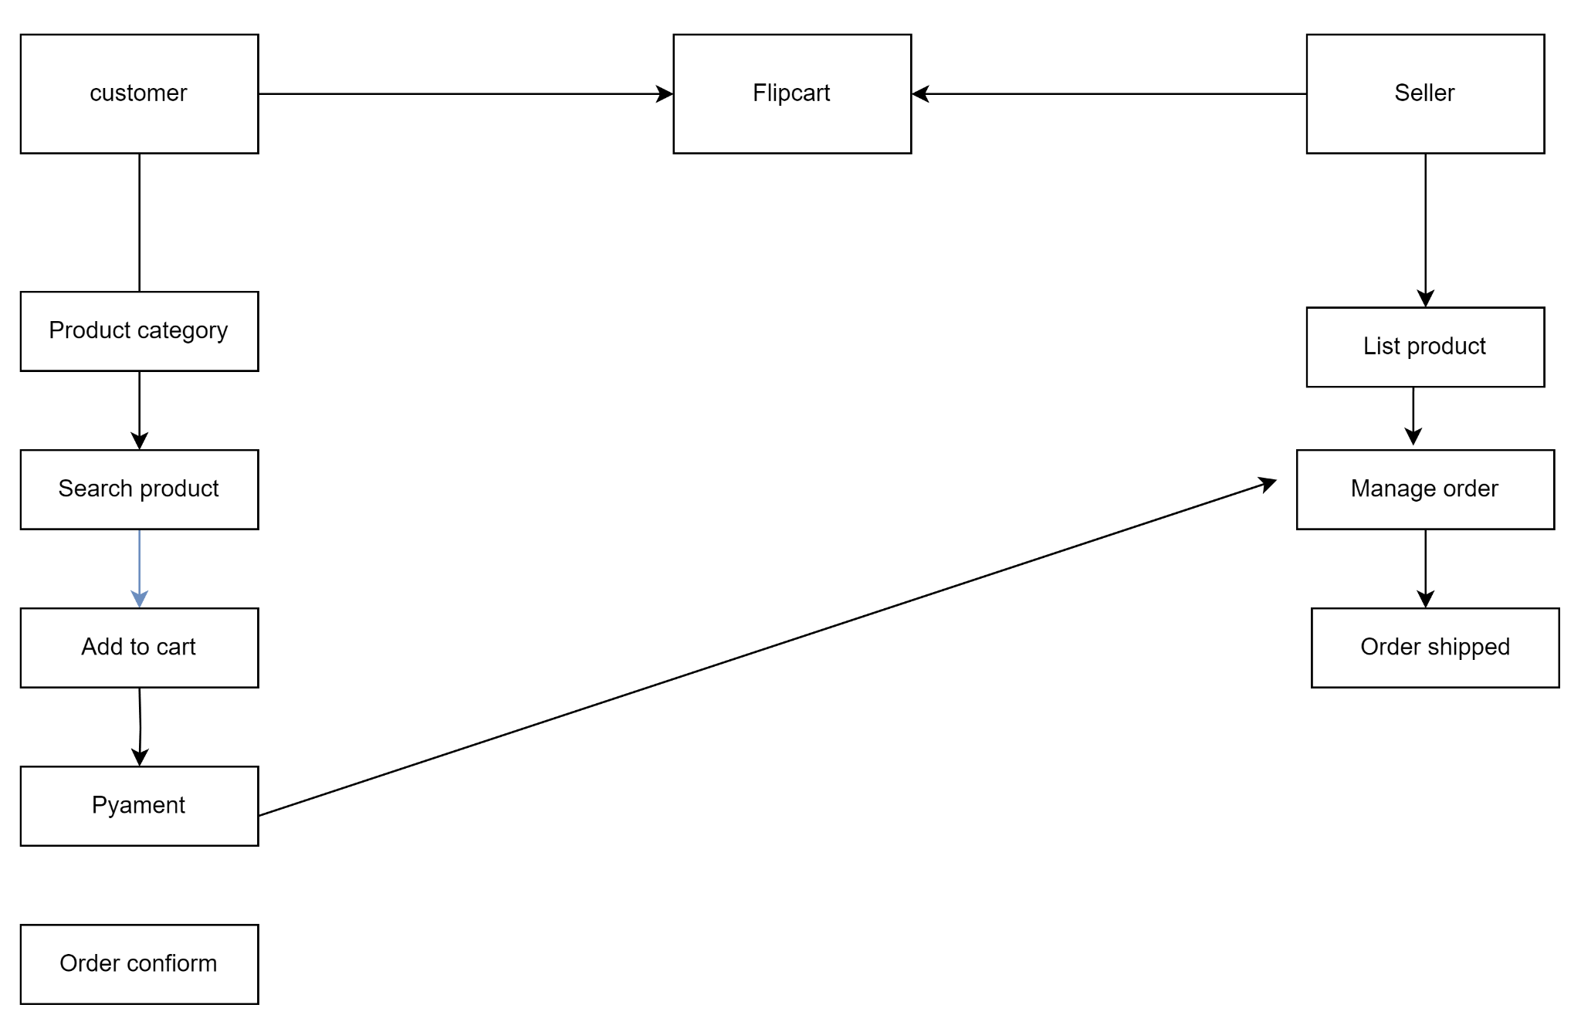

8. What is Flow chart?

- A flowchart is a diagram that depicts a process, system or computer algorithm. They are widely used in multiple fields to document, study, plan, improve and communicate often complex processes in clear, easy-to-understand diagrams. Flowcharts, sometimes spelled as flow charts, use rectangles, ovals, diamonds and potentially numerous other shapes to define the type of step, along with connecting arrows to define flow and sequence.

9. Create a flowchart to make addition of two numbers?

- 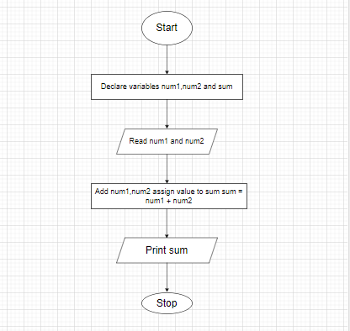

10. What is Use case Diagram?

- A Use Case Diagram is a vital tool in system design, it provides a visual representation of how users interact with a system. It serves as a blueprint for understanding the functional requirements of a system from a user’s perspective, aiding in the communication between stakeholders and guiding the development process.

11. Create a use-case on bill payment on paytm?

- 